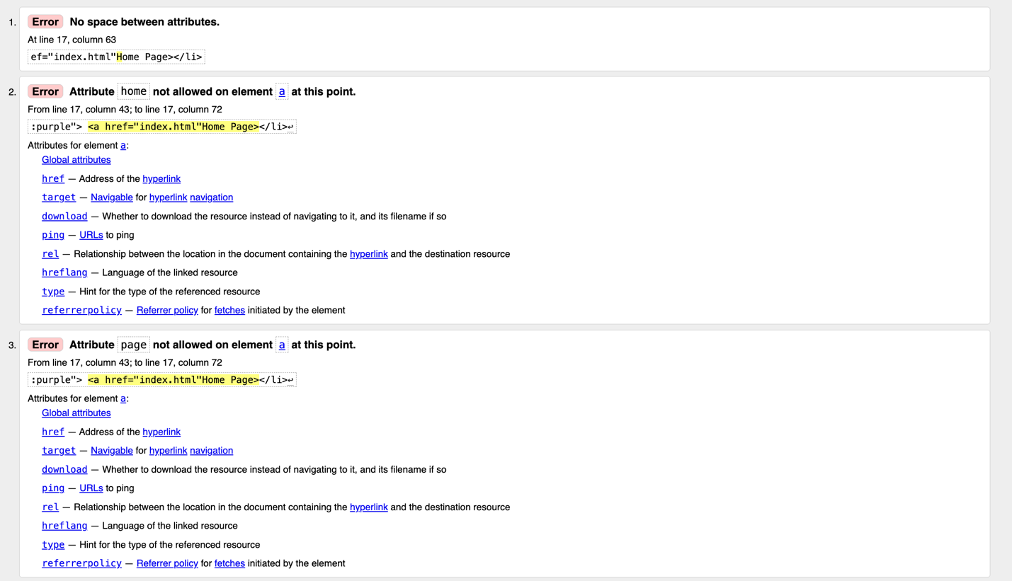
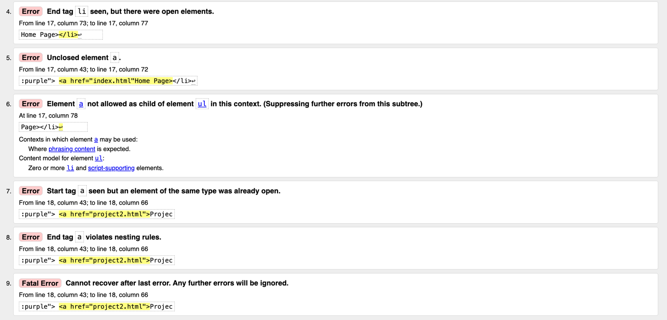
Error 1, 2, and 3: Fixed by correctly nesting the <a> attribute in the <li>
Error 4, 5, 6, 7 8 and 9: fixed by closing the <a> that was nested inside the <li>

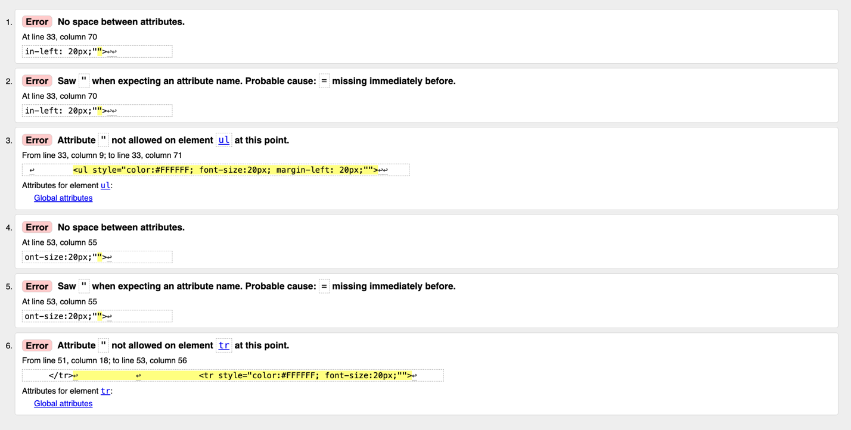
error 1 2 and 3: removed extra quotation
Error 4 5 and 6: removed extra quotation

